EXPERIMENT-4
4) Implement histogram equalization on the given image and compare it with the original image using Open CV.
- CODE
- import cv2
- img = cv2.imread("photo.jpg", 0)
- equalized = cv2.equalizeHist(img)
- compare = cv2.hconcat([img, equalized])
- cv2.imwrite("equalized_image.jpg", equalized)
- cv2.imwrite("comparison.jpg", compare)
- print("Histogram equalization completed successfully")

b) INPUT
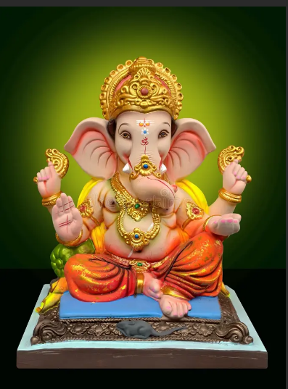
c) OUTPUT
